My design implements two new features to Facebook. First, a banner will appear at the top of the page. I’m unsure if I should make it sticky because it might annoy users if it scrolls with the user, more user testing would be needed. The banner can be closed by the small X in the corner. The banner’s goal is to advocate for better digital literacy. It provides a reminder with a link for more information. The link would lead to a Facebook site about how to recognize fake news (tips are found on NPR article assigned for reading) and a list of verified fake news sites.

The second feature auto analyzes links, a Verification Algorithm. It cross references a URL with a list of known fake news sites. Additionally, it checks the URL’s Google PageRank score. A low score suggests a made up source. It then pops up a caution message with links to help the user get more information and tips. It will never stop a user from being allow to post.

The Verification Algorithm would also scan URL’s on a user’s timeline and like flag articles it decides to be risky (ethics comes into question here, algorithm must be a good one!)

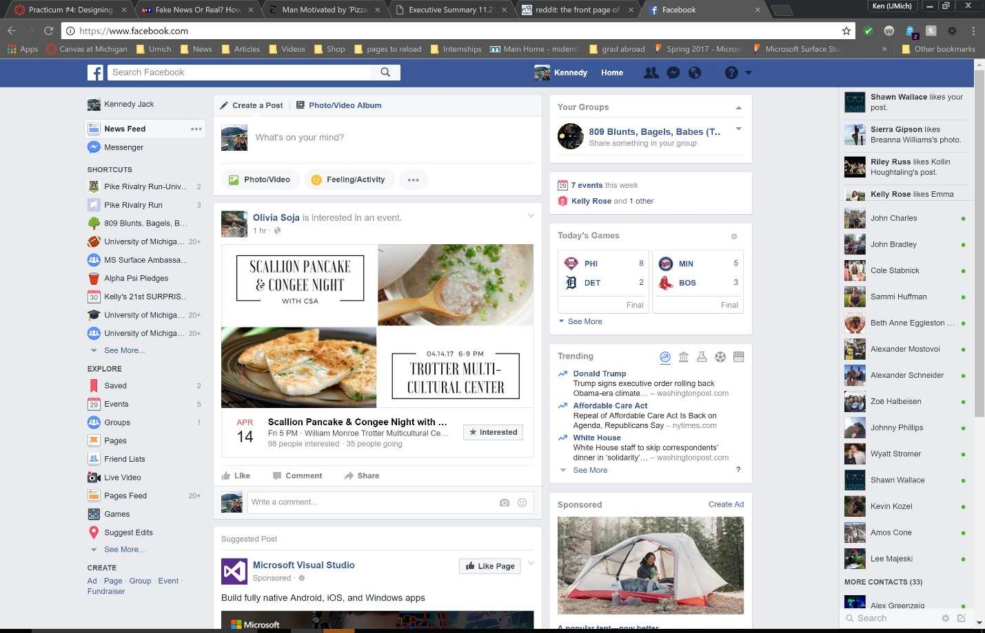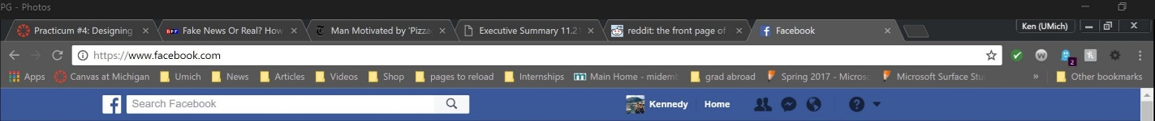

**Don’t let fake news fool you, get informed about digital literacy! Click here for some tips and tricks**

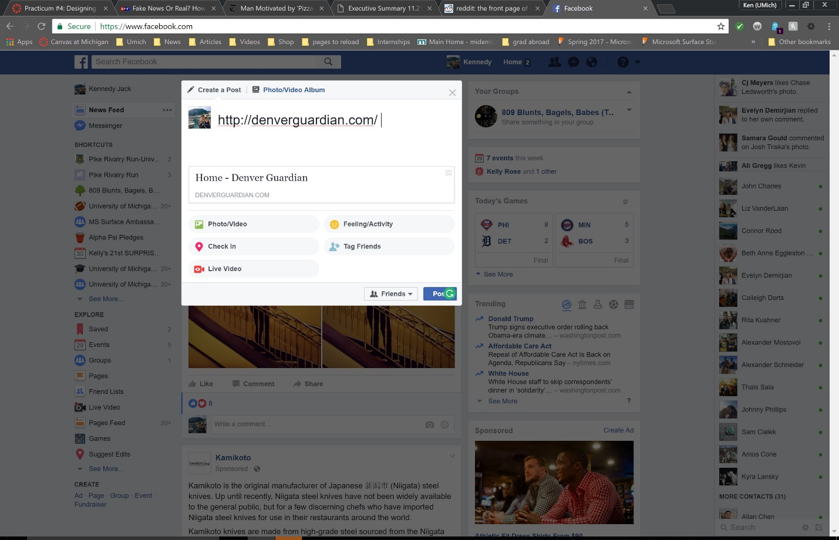

This URL was flagged as fake news, according to this site. Here is more information on fake news and what to do.